Successful completion of the following logbook will contribute to the completion of the following outcomes:
- FR24 35 Networking Technology - Outcome 3 & Outcome 5
- J0HJ 34 Computer Networking: Concepts, Practice and Introduction to Security – Outcome 3
  Networking logbook 1 | Unit Outcomes  West Lothian College  HNC Cyber Security

Section 1: Design an IPv4 addressing Scheme

Scenario:
A company currently has a B class address of 132.30.0.0 for their network. Design an appropriate IP address scheme where each subnet must accommodate 1000 hosts.

Working Space
2⁹ = 512
2¹⁰ = 1024
2x¹⁰ -2 = 1022
Total Hosts: 1024
Usable Hosts: 1022
Binary: 11111111.11111111.11111100.00000000
Subnet Mask
32 – 10 = 22 = /22
255.255.252.0/22

Complete the Table:
Number of bits needed for hosts | 10
Number of bits left for networks | 6
Number of available networks | 64
Number of usable hosts per network | 1022
Classless subnet mask | 255.255.252.0
CIDR notation | /22

Addressing Table

Subnet No | Subnet Address | 1st Usable Host | Last Usable Host | Broadcast Address
0 | 132.30.0.0 | 132.30.0.1 | 132.30.3.254 | 132.30.3.255
1 | 132.30.4.0 | 132.30.4.1 | 132.30.7.254 | 132.30.7.255
2 | 132.30.8.0 | 132.30.8.1 | 132.30.11.254 | 132.30.11.255
3 | 132.30.12.0 | 132.30.12.1 | 132.30.15.254 | 132.30.15.255
4 | 132.30.16.0 | 132.30.16.1 | 132.30.19.254 | 132.30.19.255
5 | 132.30.20.0 | 132.30.20.1 | 132.30.23.254 | 132.30.23.255
6 | 132.30.24.0 | 132.30.24.1 | 132.30.27.254 | 132.30.27.255
7 | 132.30.28.0 | 132.30.28.1 | 132.30.31.254 | 132.30.31.255
8 | 132.30.32.0 | 132.30.32.1 | 132.30.35.254 | 132.30.35.255
9 | 132.30.36.0 | 132.30.36.1 | 132.30.39.254 | 132.30.39.255
Lecturer Assigned Subnet
23 | 132.30.92.0 | 132.30.92.1 | 132.30.95.254 | 132.30.95.255

Section 2: Install and Test LAN Media

Which standard is to be used? (Tick as appropriate)
Cable Type T568A |  | Cable Type T568B | 

Describe how you attached a standard length of UTP media into a patch panel.
A UTP Cable will be attached to the patch panel by stripping the sheath of the cable allowing access to the twisted wire pair, We then will untwist the wire pair and arrange the wires into a colour coded system to be seated into the IDC strip which is also colour coded, we then punch down the wire to seat it into the terminal until we hear a click allowing us to know its properly seated. One seated we will trim off any additional excess wire to then prepare to secure the cables with ties and cable jackets. After adding these we will properly label all ports and cables to help with future testing.

Describe how testing of the cable was carried out (150 words max)
We first look at the patch panel for visible damage, any corrosion on connections or minor damage to wires. After this we do a Continuity test which is done to make sure that cables are properly setup and correctly wired. We then use a cable scanner to make sure all continuity of all wires and make sure all wires are correctly mapped. Next Throughput testing will be done to check for performance of the network if the network can keep up with the data received. Finally, we will do a Bandwidth test which should make sure there is no packet loss and data is correctly routed throughout the network. If all these pass the installation is complete

Section 3: Build Small Computer Networks
Notes:
- Simulation files are included for this section. (DO NOT ADD OR REMOVE ANY DEVICES FROM THE GIVEN SIMULATION FILES). When completed, these must be saved with your initials as part of the file name and emailed to the lecturer along with this logbook
- The network addresses will be extracted from Section 1 of your logbook

Part 1: A Peer to Peer network (Use file Sect3_Part1)
Use any of the subnets 1,2,3,6,7,8,9 to configure your network
Subnet Chosen: 1
Complete the table with your planned configuration as appropriate:

Device | Interface | IP Address | Subnet Mask | Default Gateway
PC0 | Switch0 | 132.30.4.1 | 255.255.252.0 | 132.30.4.1
PC1 | Switch0 | 132.30.4.2 | 255.255.252.0 | 132.30.4.1

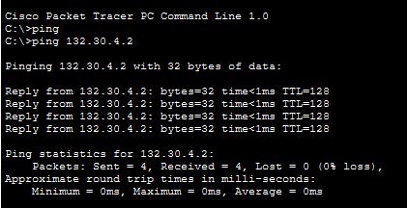

Part 2 – Produce computer network in Fig 3.2 below using an appropriate IPv4 configuration for testing connectivity
Use any of the unused subnets 1,2,3,6,7,8,9
To do: Connect all computers through a switch, use 3 pings to test connectivity
Subnet Chosen: 3
Complete the table with your planned configuration as appropriate:

Device | Interface | IP Address | Subnet Mask | Default Gateway
PC0 | Switch0 | 132.30.12.1 | 255.255.252.0 | 132.30.12.1
PC1 | Switch0 | 132.30.12.2 | 255.255.252.0 | 132.30.12.1
PC2 | Switch0 | 132.30.12.3 | 255.255.252.0 | 132.30.12.1
PC3 | Switch0 | 132.30.12.4 | 255.255.252.0 | 132.30.12.1
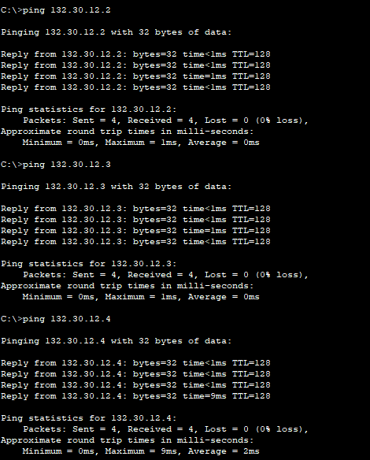

Testing

Explain how you plan to test for connectivity. Your tests must be comprehensive and test all of your configurations. Provide screen shots for all tests carried out.

Plan: Ping all other computers from first computer using the terminal with ping (Other pc address)

Part 3 – Expand the network created in Fig3.2. to produce network in Fig3.3

- Configure using IP scheme from Section 1
- Subnet 4* should obtain IP configuration automatically
- Default gateway address for subnets should be first useable IP address in range
- DHCP server should use second usable IP address in subnet 4* range
- (The learner is required to configure the network settings of the server, however they are not required to configure the DHCP scope)
Complete the table with your planned configuration as appropriate:
Device | Interface | IP Address | Subnet Mask | Default Gateway
DHCP Server | Switch0 | 132.30.16.2 | 255.255.252.0 | 132.30.16.1
PC0 | Switch0 | 132.30.16.3 | 255.255.252.0 | 132.30.16.1
PC1 | Switch0 | 132.30.16.4 | 255.255.252.0 | 132.30.16.1
PC2 | Switch0 | 132.30.16.5 | 255.255.252.0 | 132.30.16.1
PC3 | Switch0 | 132.30.16.6 | 255.255.252.0 | 132.30.16.1
PC4 | Switch1 | 132.30.20.2 | 255.255.252.0 | 132.30.20.1
PC5 | Switch1 | 132.30.20.3 | 255.255.252.0 | 132.30.20.1
PC6 | Switch1 | 132.30.20.4 | 255.255.252.0 | 132.30.20.1
PC7 | Switch1 | 132.30.20.5 | 255.255.252.0 | 132.30.20.1
Router 0 | Fa0/0 | 132.30.16.7 | 255.255.252.0 | N/A
 | Fa0/1 | 132.30.20.6 | 255.255.252.0 | N/A

Testing
Explain how you plan to test for connectivity. Your tests must be comprehensive and test all of your configurations. Provide screen shots for all tests carried out. I will also make sure the DHCP is correct by checking assigned Ips and everything is in the right subnet
NOTE: You will need to take note of the DHCP addresses assigned to the clients
To test this network we will separate it into 3 main sections:
- Subnet 4 connectivity
- Subnet 5 connectivity
- Confirm connectivity between subnet 4 and subnet 5

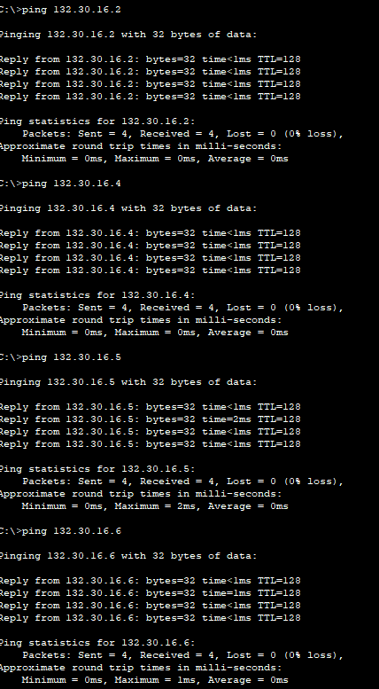
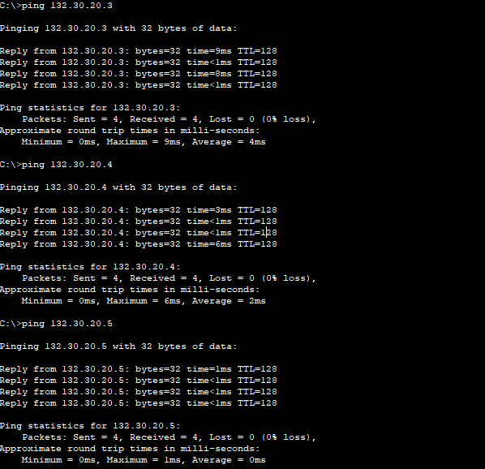
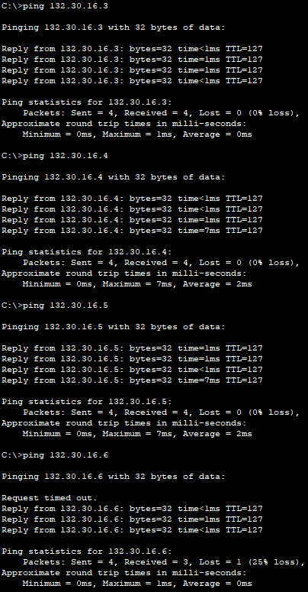

Items to be upload to Moodle | Check
Working Simulation File for Sect3_Part1_Initials | 
Working Simulation File for Sect3_Part2_Initials | 
Working Simulation File for Sect3_Part3_Intitials | 

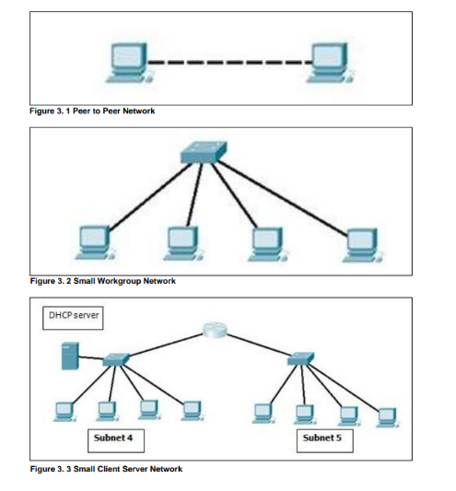

*** At this stage, the log book should be submitted to your lecturer for marking***

Section 4: You have been tasked with setting up a secure wireless network for a local charity.

Using the charities current network (configured in section 3, Fig3.3), you are being asked to add the appropriate hardware and security measures to incorporate a wireless portion to the network.

Stage 1 – Device a list of equipment that will be required to allow wireless technology to be implemented within the local charity.
3 laptops
1 home router
Stage 2 – Obtain and setup the wireless equipment, describe/log/picture log/vlog the steps to achieve this build.
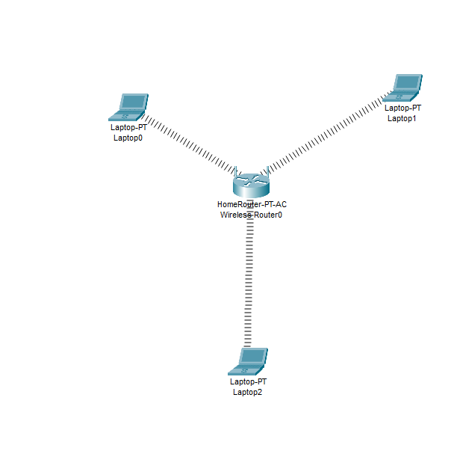

I setup 3 laptops with the Linksys-WPC300N modules that allow a 2.4GHz connection to allow us to connect to the HomeRouter-PT-AC wireless Router. This allowed all 3 Laptops to be able to connect as there isn’t currently any security measures in place.

Stage 3 – Devise and implement a suitable authentication and encryption scheme to allow users to use the wireless network.
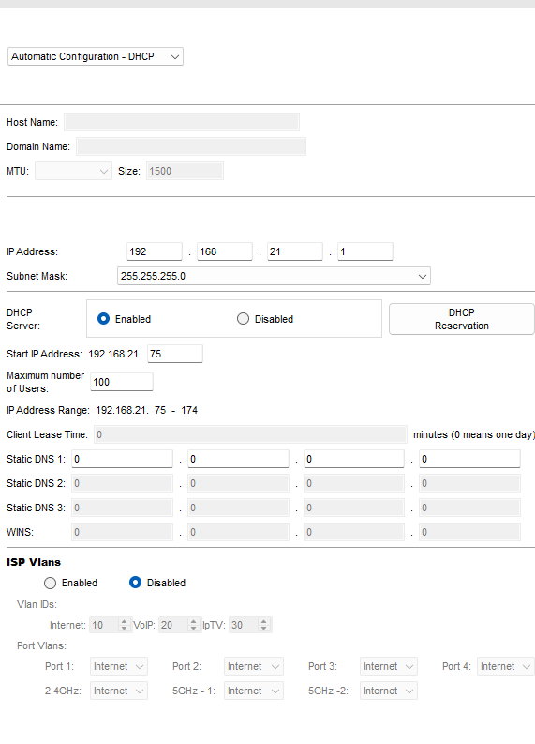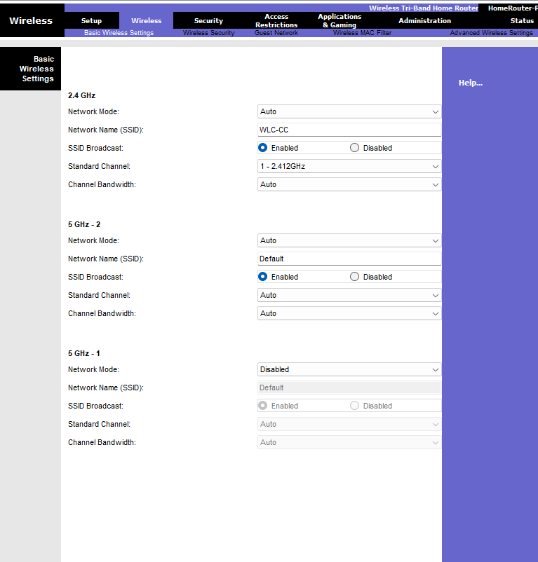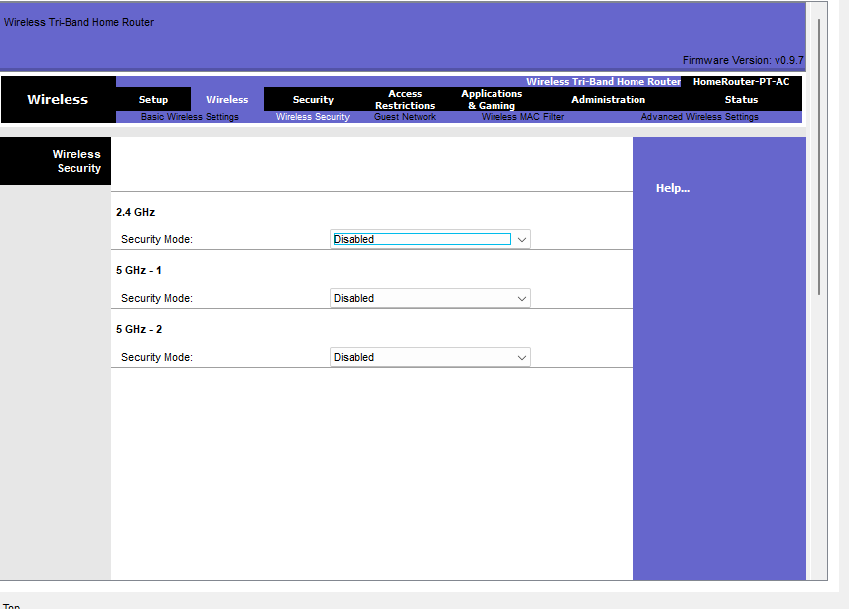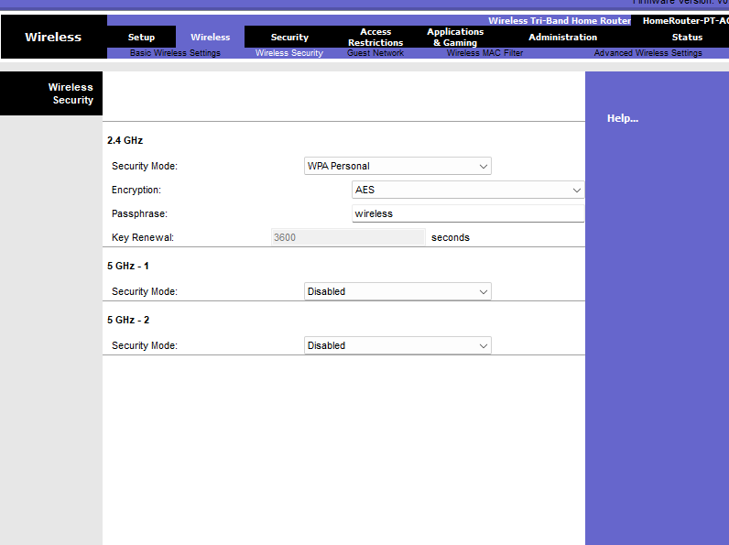

I changed the IP address to 192.168.21.1 and a start Address of 192.168.21.75 with DHCP enabled. Then we enabled the 2.4Ghz security mode of WPA Personal with AES and a passcode of “Wireless”
Stage 4 – Implement wireless MAC address filtering to further secure the wireless network
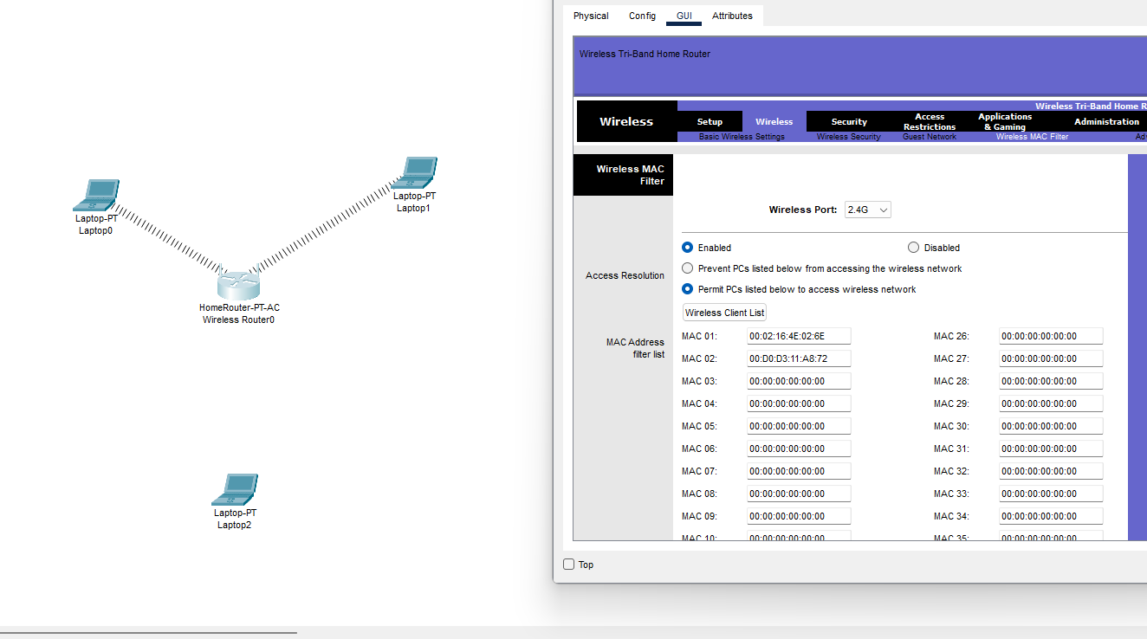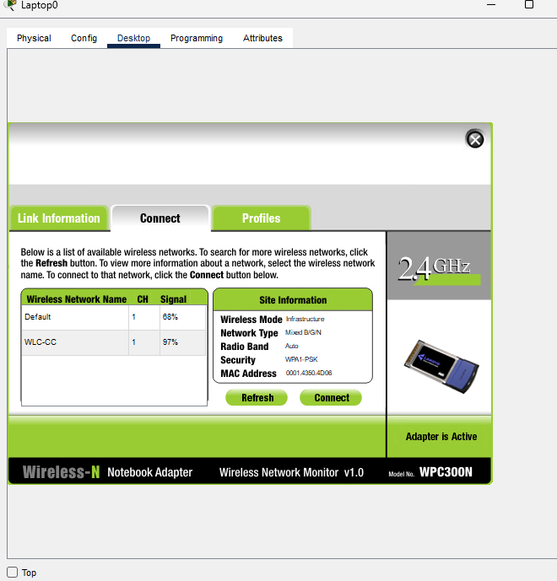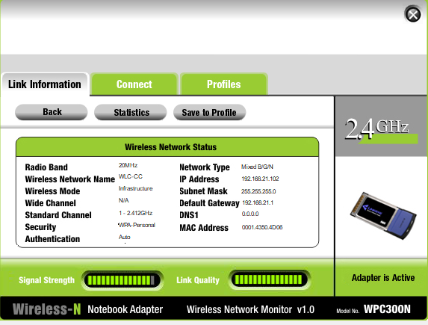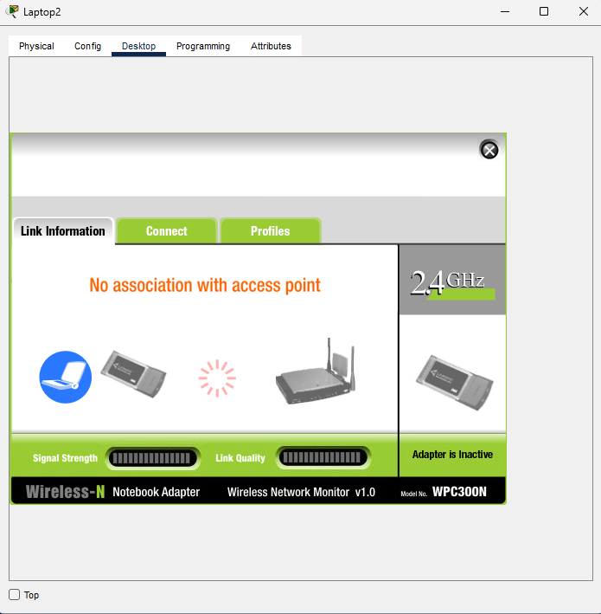
Next, I got the MAC addresses of the laptops 1&2 by going to the command prompt of both laptops and typing “ipconfig /all” and getting it from the wireless section. After this I went to the wireless section and the wireless MAC Filter subsection. I enabled it and then turned on the “permit” option. After this I added both MAC addresses to the table which allowed both laptops 1&2 to connect but not laptop 3. I then made sure all other wireless ports did not permit anything to be able to connect to them.

Student Checklist
Action | Complete?
Section 1 – Design an IPv4 Addressing Scheme
- Includes working, address table and lecturer assigned subnet
Section 2 – Install and Test LAN Media
- Includes description of installation and testing
Section 3 – Build Small Computer Networks
- Includes screenshots and testing of each network as well as additional packet tracer files
Section 4 – Set up a Secure Wireless Network
- Includes description and screenshots/screen recordings where appropriate

